




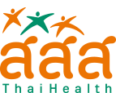
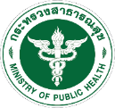
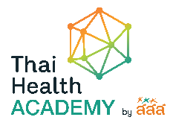
Thai UHC Journey Workshop 2024
“Health Promotion: A Transformative Path Towards Sustainable Health and Well-being”
4-8 November, 2024 in Bangkok, Thailand

*To be signed by your supervisor (the head of the relevant department / division of your organization).

I have examined the documents in this form and found them true. Accordingly, I agree to nominate …(Name and position of applicant)….. on behalf of our organization.

Date: |  |  | Signature:
Name:
Title / Position
Department / Division
Email

